Annual General Meeting Agenda

Engineering Society of Queen’s University
Thursday, March 22th, 2018
6:00 pm, Jeffery Hall 127

- Attendance
- Adoption of the Agenda: Motion 1
- Adoption of the Minutes: Motion 2
- Break
- Speakers Business
- Presentations
- Break
- Executive Oath
- New Business: Motions [3-4]
- Executive Reports
  - President
  - VP (Operations)
  - VP (Student Affairs)
- Director Reports
  - Communications
  - Community Outreach
  - Conferences
  - Design
  - Events
  - Finance
  - First Year
  - Human Resources
  - Information Technology
  - Internal Affairs
  - Professional Development
  - Services
- Question Period
- Faculty Board Report
- Alma Mater Society Report
- Senate Report
- Engineering Review Board Report
- Advisory Board Report
- Equity Officer Report
- Club Reports (Happy)
  - Mechanical
  - ECE
  - Eng Phys
  - Mining
  - Apple
  - Civil
  - ChemEngChem
  - Geological
- Year Reports
  - Sci’18
  - Sci’19
  - Sci’20
  - Sci’21
- Statements and Questions by Members

Speaker: Jamil Pirani
Secretary: Isabela Dominguez

Motion List

Motion 1

Whereas: It’s the Annual General Meeting;
& whereas: that means everyone gets a vote today!

BE IT RESOLVED THAT:
The Engineering Society and its members approve the agenda of the Annual General Meeting of Thursday, March 22th 2018 as seen on the Engineering Society website.

Moved by: Alexander “Almost fired” Clifford
Seconded by: Jamil “Almost retired” Pirani

Motion 2

Whereas: Do you remember what happened at our last AGM?
& whereas: it was a long time ago;

BE IT RESOLVED THAT:
The Engineering Society and its members approve the minutes of the Annual General Meeting of Thursday, March 9th 2017 as seen on the Engineering Society website.

Moved by: Alexander “I love AGM” Clifford
Seconded by: Isabela “I only like AGM as a friend” Dominguez

Motion 3

Whereas: The Advisory Board of the Engineering Society needs new members;
& whereas: the Annual General Meeting is the time to elect those members;

BE IT RESOLVED THAT:
__________, _________, and __________ be elected as two-year members of the Advisory Board of the Engineering Society.

BE IT RESOLVED THAT:
___________, __________, __________ and __________ be elected as one-year members of the Advisory Board of the Engineering Society.

Moved by: Tyler “I advise you to run” Snook
Seconded by: Jillian “You won’t be bored” Reid

Motion 4

Whereas: The alumni and Faculty members of the Advisory Board of the Engineering
Society are to be “annually nominated by the executive”;

BE IT RESOLVED THAT:
_________ and _________ are elected as Faculty representatives for the Advisory Board of the Engineering Society for a one-year term.

BE IT RESOLVED THAT:
_________ and _________ are elected as Alumni representatives for the Advisory Board of the Engineering Society for a one-year term.

Moved by: Carson “Skate fast” Cook
Seconded by: Behshid “wrong kind of board” Behrouzi

Motion 5

Whereas: It’s good to own land!
& whereas: The Engineering Society and Research Center (Kingston) allows us to hold it;

BE IT RESOLVED THAT:
The Queen’s Engineering Society and its members recognize that Carson Cook, Behshid Behrouzi , and Emily Wiersma will sit on the Engineering Society and Research Centre (Kingston) Board of Directors as of May 1st 2018.

Moved by: Behshid “EngSocLand!” Behrouzi
Seconded by: Emily “Where’s that?” Wiersma
Thirded by: Carson “Left at the peppermint forest and just past the Gumdrop Mountains” Cook

Motion 6

Whereas: Jamil is old and it’s time for him to retire;
& whereas: we need to find his replacement;

BE IT RESOLVED THAT:
__________ be elected as the Speaker and Chief Electoral Officer of the Engineering Society.

Moved by: Alexander “Bye grandpa” Clifford
Seconded by: Julianna “We’ll visit you in the weekends” Jeans

Motion 7

Whereas: Carson, Besh and Emily are sad they are losing their old team;
& whereas: here’s a new team;

BE IT RESOLVED THAT:
The following be ratified by the Annual General Meeting for their respective positions:
- Sidney Picco as the Director of Academics
- Alex McKinnon as the Director of Communications
- Sam Roper as the Director of Conferences
- Hatem Dawaghreh as the Director of Design
- Miranda Bundgard as the Director of Events
- Zaid Kasim as the Director of External Relations
- Brandon Tseung as the Director of Finance
- Emma Prairie as the Director of First Year
- Kodie Becket as the Director of Human Resources
- Max Karan as the Director of Information Technology
- Isabela Dominguez as the Director of Internal Affairs
- Juliana Brown as the Director of Professional Development
- Tristan Brunet as the Director of Services

Moved by: Behshid “I’m going to miss the old team” Behrouzi
Seconded by: Emily “I won’t” Wiersma
Thirded by: Carson “EDgy” Cook

Executive Reports

President – Nathaniel Wong

president@engsoc.queensu.ca
Congratulations to all the graduating students who received their Iron Ring!!
Hiring
- Lots of applications are up on EngSoc Apply! Everyone should apply!
Undergraduate Orientation Review Working Group
- Recommendations were released: http://www.queensu.ca/principal/priorities-and-initiatives/undergraduate-orientation-review-working-group
Sponsorship Caucus #2
- Had our 2nd Sponsorship caucus last week which was great, we talked about transitioning sponsorship contacts from year to year among many other topics
- Thanks for everyone who came out
- Shout out to my FYPCO Helen for doing a great job this year
Transitioning
- Continuing to let Carson run most of our statics and has been attending any meetings with the faculty
Next 2 Weeks
- Banquet
- AGM

VP (Operations) – Jill Reid

vpops@engsoc.queensu.ca

Worked on

- transitioning Besh

- service Manager Contracts

- CU advertising contract

- organizing Services books

- getting ready to hand over the keys to Besh!

Next week

- finishing up service contracts

- figuring it alarm system mix up

- Finnish transitioning!!

VP (Student Affairs) – Julianna “JJ” Jeans

vpsa@engsoc.queensu.ca

Hi Everyone!

In the past little while I’ve sat on both the AMS Sustainability action fund granting committee and the AMS Equity Grant granting committee. Emily and I have been working on a lot of transitioning so she’s ready to hit the ground running in the summer! As usual here’s a bunch of reminders from me

Opportunities to get Involved:
There are a ton of applications open on EngSoc Apply! If you have any questions about where to start feel free to give me a shout. Check out some of the opportunities available:
https://webapp.queensu.ca/ams/AMSapply/ENGSOC/

Engenda:
If you have any cool photos that you think should be included, please send them to Matt (the best FYPCO ever) at agenda@engsoc.queensu.ca!

Event Sanctioning:
Please remember to have your events sanctioned through the AMS event sanctioning process:
http://myams.org/event-sanctioning-form/

If you have any questions about this process please do not hesitate to contact me!

Volunteer of the Month:
If you would like to nominate someone you know for volunteer of the month for the month of January, submit nominations here:
https://form.jotform.ca/engsocvpsa/volunteer-of-the-month-nominating-f

I hope you’re all doing well!

All the best,
JJ

Director Reports

Communications – Behshid Behrouzi
communications@engsoc.queensu.ca
Hello Council!

Things that you’ve been doing over the past two weeks:
- Transitioning Alex
- Team meetings
- Taking up a new videography project with the faculty
- Hiring graphics and Facebook posts

Things that you will be doing over the next two weeks:

- LinkedIn Headshots
- Ordering equipment for the headshots
- Uploading photos from events we’ve covered to Facebook

Cheers,
Besh

Community Outreach – Jordan Pernari
outreach@engsoc.queensu.ca

Hi Council!

Here’s what I’ve been up to over the past few weeks:
- Served a meal at Martha’s Table with my FYPCO, Claire;
- Helped Fix n Clean Coordinators work on their transition documents;
- Worked on organizing the ESSCO Blood Drive;
- Ran the March ExCommCom meeting;
- Worked on ExCommCom information gathering and sent some emails;
- Worked with ASUS Kids for Kids to organize and run the annual Cover Your Crest competition;
- Continued transitioning Zaid!

Over the next two weeks I will be:
- Continuing to work with my Fix n Clean Coordinators and COT Chair on their transition documents;
- Continuing to oversee the ESSCO Blood Drive competition;
- Continuing to transition Zaid.

Hope everyone has had a good few weeks!

Jordan

Also, here’s a cute pic of our kiddos after they won the championship!

Conferences – Aidan Thirsk
conferences@engsoc.queensu.ca

Design – Oliver Austin
design@engsoc.queensu.ca

Hey Council,

Things I’ve been doing over the past two weeks:
- Working on my mixtape
- Organizing roundtable
- Transitioning my boy Hatem
- Space allocation
- Meeting with Simon Smith about optimizing design bay space

Things that I will be doing over the next two weeks:
- Holding down the fort.
- Space allocation
- Transitioning my boy Hatem

Happy AGM, may the pizza be plentiful and the motions short.
Oliver

Events – Leah Vignale
events@engsoc.queensu.ca

Finance – Sarah Rodin
finance@engsoc.queensu.ca

Hi Council!

Here are several things I have done since last council:
- Deposits
- Iron ring sales
- Helped people with cheque reqs
- Month-end updates to bookkeepers
- Transitioning Brandon
- Budget updates

Here are several things I’ll be working on in the next two weeks:
- Continuing transition

Have a lovely rest of your week!

Sarah Rodin

First Year – Nick Dal Farra
firstyear@engsoc.queensu.ca

Feliz Navidad,

Things that I’ve been doing over the past two weeks:
- Transitioning Emma
- Ran a First Year talent show

Things that I will be doing over the next two weeks:
- Saying goodbye to all my friends
- Living fast and dying young

(insert cheesy speech here)

Aidan has not given me my secret Santa gift!
For the final time, skate fast my friends.

Yer boi Nick Dal Farra

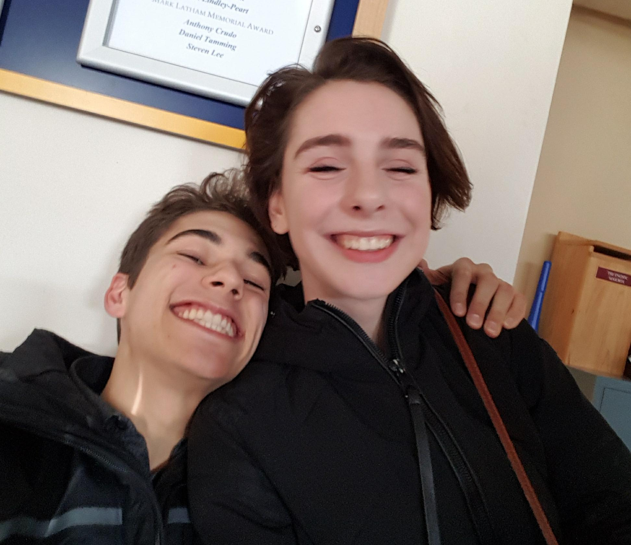

Human Resources – Emily Wiersma
hr@engsoc.queensu.ca
Hello Council!

What I’ve Done:
- Putting applications up on EngSoc apply
- Answering questions about EngSoc apply
- Hiring training by request
- Started meeting with Kodie (incoming HR)
- Planning training conference (March 25, 1 - 4 in Ellis Aud)

What I’ve Got Going On:
- Meeting with HR team
- Updating EngSoc apply
- Transitioning Kodie
- Transition with Julianna

Remember to take time for self-care! I tried to hang out with a cat this week
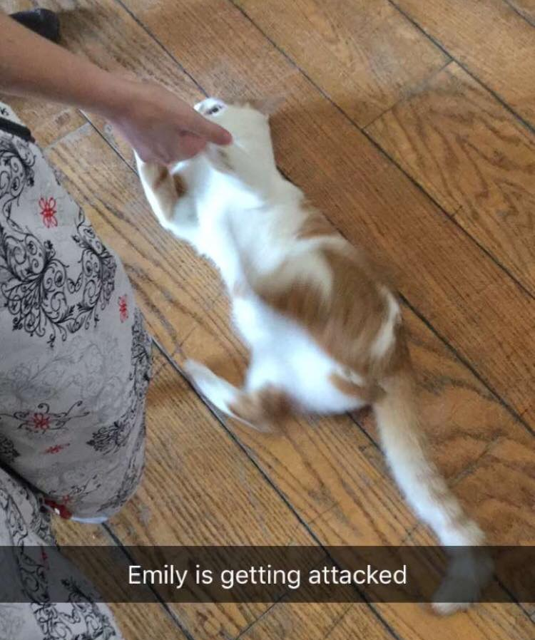

Emily

Information Technology – Carson Cook
doit@engsoc.queensu.ca

Hey Council,

Things done since last council:
- Dash is secure! Nearly in production!
- Transitioning Max – he’s great!
- Max made a new webserver – updated version
- Working with Max to fix DoIT policy
- Working with Max to structure new Operations team
- Working with Max to hire the new IT Managers
- FYPCO and ITOC ran a great C++/OOP Workshop!

Things that I will be doing over the next two weeks:
- Creating/presenting cloud workshop
- Working with Peter/ITS to get SSO environment to production mode for Dash
- Consulting SciFormal on their new hour logger/ticket application
- Continuing to transition Max

Download QLife!

It’s been a great year everyone! I will miss being DoIT so much

Have a good two weeks,

Carson Cook

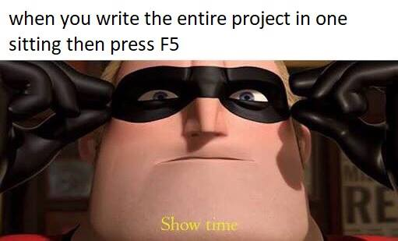

Internal Affairs – Alexander Clifford
iaffairs@engsoc.queensu.ca

Professional Development – Hannah Cameron
pd@engsoc.queensu.ca

Services – Cody McLaughlin
services@engsoc.queensu.ca

