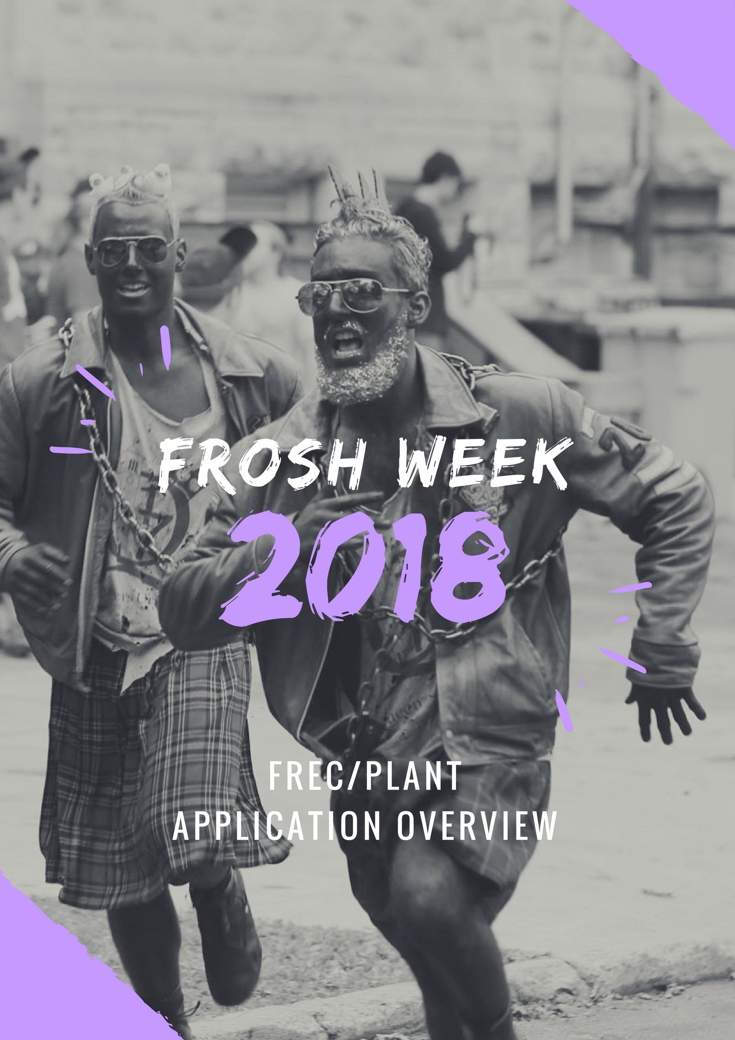

Photo by Cam Berry for Studio Q
PREAMBLE
Frosh week is an amazing time of year where we welcome the incoming class with the same energy, excitement, and support we were all welcomed with in our first year. For many, the experience of being a FREC is just as, if not more, amazing than their experience as a frosh. If you look back on your Frosh Week as one of the best weeks of your life, or if your FRECs have had a positive impact on your experience in Queen’s Engineering so far, then we hope you’ll apply to be a FREC this year and help us maintain this amazing tradition!
You may or may not have realized this, but being a FREC is much more than just being purple, intense, and a special kind of crazy for 5 days. We organize an entire week of training to help our FRECs be amazing leaders, mentors, and supports not just for Frosh Week, but for the entire year afterwards! To that end, if you’re questioning whether or not you’d be a good FREC, don’t just think about Frosh Week itself but everything that might come after – because that’s what we’re also looking at.
On FC, it’s our goal to organize and execute the best possible Frosh Week for the incoming class of 2022, and we can’t possibly do that without hiring the best FRECs. In fact, without the best FRECs we really can’t do much at all, which is why we take this process so seriously, and you should too!
The FREC Hiring Process is split into the following 3 components:
- The Individual Application
- The Group Application
- The Group and Individual Interviews
To be hired as a FREC, applicants must complete all 3 components of the process. Electronic copies of both the individual and group applications must be submitted to frec@engsoc.queensu.ca by Wednesday January 17th, 2018 at 6:00 pm.
We’re looking forward to next September, but we can’t get there without hiring some amazing FRECs first. Hopefully you’re excited at the opportunity to be a FREC! If you have any questions, please don’t hesitate to reach us at frec@engsoc.queensu.ca!

On behalf of the rest of FREC Committee ’18,
Owen Kent, Chief Frec & Delaney Benoit, Orientation Chair

INDIVIDUAL APPLICATION
This component of the application consists of an identification card, a bio, and a creative component. In your bio, tell us about yourself and why you’d make a great FREC or plant. Your bio must be at least 300 words, and no more than 500 words. The creative component is a blank page on which we want you to show us what Frosh Week means to you, in whatever medium you prefer to express yourself! We use the bios to assess each applicant’s qualifications to be a FREC, while we use the ID cards to help distinguish you from everyone else. The creative component is a supplemental opportunity to express your individuality to FC.

You can find the individual applications on the EngSoc Website at https://engsoc.queensu.ca/index.php/get-involved/first-year-involvement/.

GROUP APPLICATION
Applicants must form groups of 4 – 5 individuals and submit a group application which summarizes contact information for each member. There are no gender ratio restrictions on application groups. You will be interviewed with your group, but all hiring decisions are made on an individual basis. This group is for interviewing purposes only. FREC groups will be formed after the hiring process is complete.

You can find the group applications on the EngSoc Website at https://engsoc.queensu.ca/index.php/get-involved/first-year-involvement/.

APPLICATION SUBMISSION
When completed, one group member must send the following to frec@engsoc.queensu.ca by Wednesday, January 17th, 2018 6:00 p.m.
- Electronic copies of your each group member’s individual applications
- The group application
The subject line should be: “FREC Applications – First Initial and Last Names”
Note that only one submission per group is required.
e.g. Subject Line: “FREC Applications – O. Kent, T. Haas, S. White, M. Liblong, J. Maine”
INTERVIEW PROCESS
Every applicant that submits a completed application before the deadline of Wednesday, January 18th will be granted an interview. Applications must be in compliance with the word count requirements in order to be deemed complete.
Interviews will be held on Friday evenings, and on Saturdays and Sundays, starting from Friday, January 26th and ending Sunday, February 11th. Interview times will be given on a first-come, first-serve basis at the FREC Sign-up Session. Each interview time slot is an hour long and one member from each group will be responsible for selecting a time slot that works for their entire group – i.e. your group representative should know which times absolutely will not work and which times your group would prefer.
You will want to arrive at least 15 minutes early for your interview.
Each interview period consists of 3 parts:
- A skit performed by the group - 5 minutes
- A group interview consisting of 2 serious questions – 5 minutes
- Individual interviews, each 8 minutes long, consisting of 6 questions – 40 minutes

The Group Skit
The group interview will begin with a 5 minute skit that your group has prepared in advance. You may bring any props or costumes your skit requires, as long as they do not violate the rules stated below. The purpose of these skits is to see how you step out of your comfort zone with your friends. So have fun, be weird, and feel free to incorporate members of your interview panel in whatever you decide to do. Ultimately, this is your opportunity to break the ice with your interview panel and unless you break any of the following rules; your skit will have very little impact on your interview.
There are certain lines that have been crossed in the past, that will disqualify your group:
- No nudity
- No slamming
- No purpling
- No raw meat, fish, pet food (it’s happened)
- No obscene or excessive profanity
- No alcohol or drugs
- No direct insults towards other faculties
- The room must be in the same condition when you leave as when you entered (including smell)

Please do not ruin a perfectly good application by crossing any of these lines.

The Group Interview
Immediately after your skit, we will ask you 2 serious questions related to Frosh Week, being a FREC after Frosh Week, various group situations etc. For each question you will have 2.5 minutes to converse and determine how you will respond as a group, and respond directly. The intent of this is to determine how you work with a group to address a situation.

The Individual Interview
After the group interview, we will ask you to leave the room while we prepare for individual interviews. A member of FC will be waiting outside to help coordinate. Each individual interview will be precisely 8 minutes long and will consist of 6 questions. Each question will be related to Frosh Week or being a FREC in some way, with the last question being a joke question meant to help us get a sense for your personality.

Additional notes
We have dozens of questions to choose from, so each interview process will be unique and will almost certainly be different from the exact questions anyone else in your group or any of your friends got in their interviews. The best way to prepare for these interviews is to do mock interviews with your group using your own questions that are related to Frosh Week. Anything from specific events to random situations before, during and after Frosh Week, certain topics such as Accessibility and Inclusivity, International Frosh, or Mental Health and support are all good places to start. Your FRECs are great resources for these discussions, and past members of FC can also help you!
Hiring of FRECS and Plants will be done simultaneously. If you’re interested in being a Plant you will be able to indicate this on your individual application, which will guarantee that a plant-specific question will be asked in your interview.

FINAL NOTE
We will be hosting a FREC Application Info Session in early January where we will introduce every member of FC ‘18 and do a comprehensive review of the hiring process. There will also be a presentation at the First Year Conference from Garrett (Chief ’16) about being a FREC. You’re encouraged to attend both events and to ask any questions you may have. Of course you can also email us at frec@engsoc.queensu.ca with any questions!
Good Luck!
- Frec Committee ’18

